Familiarization Programme (2019-2020)

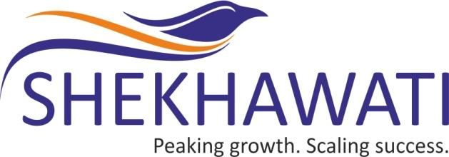

SHEKHAWATI
POLY-YARN
LIMITED
(CIN No.: L17120DN1990PLC000440)

Registered Office : Plot No. 185/1, Naroli Village, Near Kanadi Phatak, Silvassa, D & N.H.- 369230.

Corporate Office : Express Zone, A-Wing, Unit No.1102-1103, 11th Floor, Patel Vatika , Off. Western Express Highway, Malad (East), Mumbai - 400 097
Tel : 022-66940626/022-62360800
Website : www.shekhawatiyarn.com E-mail Id : cs@shekhawatiyarn.com

During the financial year 2019-20, the following familiarization programmes were held by the Company for the Independent Directors and Board of Directors of the Company:

Sr. No. | Subject matter | No. of programmes |  | No. of hours spent by the Independent Directors and Board of Directors
 |  | FY 2019-20 | Cumulative Till date | FY 2019-20 | Cumulative Hours Till date
1 | Review of business and operations | 4 | 4 | 2 | 2
2 | Revised Secretarial Standards on Board (SS-1) and General Meetings (SS-2) | 1 | 1 | 0.5 | 0.5
3 | SEBI (Listing Obligations and Disclosure Requirements) Discussion on amendments of SEBI LODR provisions | 2 | 2 | 1 | 1
4 | Presentation to acquaint with the latest amendments in various Rules under the Companies Act, 2013 | 1 | 1 | 1 | 1

